Lab Report

By: Jahmil Ally (501045419)

# Observations and Analysis

## Q1:

I converted my past lab 2 into Python to implement this lab to test for branch and statement coverage. Using “coverage run --branch -m unittest discover -s test” and “coverage html” I was able to get the results.

The 8 missing statements for execution from IMoney.py is from the 8 functions that have a pass statement which never get executed as it is an interface. The 2 other missing lines belong to the mains for each respective test.

In order to test mutation testing in python I had to open my project in docker using “docker run -it --rm -v "C:\Users\jazza\Documents\Coding Projects\COE891Labs\lab6:/app" python:3.9 bash”

I installed my necessary requirements “pip install -r requirements.txt” and then ran the command to test. This uses various methods of mutation such as:

* Integer literals are changed by adding 1. So 0 becomes 1, 6 becomes 7, etc.
* < is changed to >=
* break is changed to continue and vice versa
* The mutations would be as subtle as possible. See mutmut __init__.py for the full list.

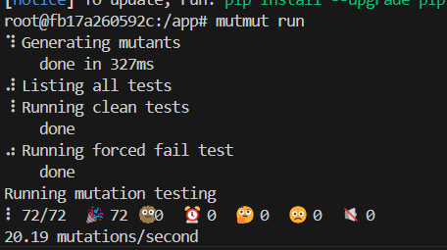

# Appendix:

## Q1:

### IMoney.py

### Money.py

### MoneyBag.py

### test_Money.py

### test_MoneyBag.py

